**Sri Ranganathaswamy Temple**

The **Sri Ranganathaswamy Temple** is a [Hindu temple](https://en.wikipedia.org/wiki/Hindu_temple) dedicated to [Ranganatha](https://en.wikipedia.org/wiki/Ranganatha), a form of the Supreme God, Maha [Vishnu](https://en.wikipedia.org/wiki/Vishnu), located in [Srirangam](https://en.wikipedia.org/wiki/Srirangam" \o "Srirangam), [Tiruchirapalli](https://en.wikipedia.org/wiki/Tiruchirapalli" \o "Tiruchirapalli), [Tamil Nadu](https://en.wikipedia.org/wiki/Tamil_Nadu), India.[[4]](https://en.wikipedia.org/wiki/Ranganathaswamy_Temple,_Srirangam#cite_note-unescosrirang-4) Constructed in the [Dravidian architectural style](https://en.wikipedia.org/wiki/Dravidian_Architecture), the temple is glorified by [Alvars](https://en.wikipedia.org/wiki/Alvars) in their [Divya Prabhanda](https://en.wikipedia.org/wiki/Naalayira_Divya_Prabhandham" \o "Naalayira Divya Prabhandham)[[5]](https://en.wikipedia.org/wiki/Ranganathaswamy_Temple,_Srirangam#cite_note-FOOTNOTEDavid_N._Lorenzen200552%E2%80%9354,_87%E2%80%9393-6) and has the unique distinction of being the foremost among the 108 [Divya Desams](https://en.wikipedia.org/wiki/Divya_Desams" \o "Divya Desams) dedicated to The Supreme God Vishnu.

It is the most illustrious [*Vaishnava*](https://en.wikipedia.org/wiki/Vaishnava) temples in [South India](https://en.wikipedia.org/wiki/South_India) rich in legend and history. The temple has played an important role in [Vaishnavism](https://en.wikipedia.org/wiki/Vaishnavism) history starting with the 11th-century career of [Ramanuja](https://en.wikipedia.org/wiki/Ramanuja) and his predecessors [Nathamuni](https://en.wikipedia.org/wiki/Nathamuni" \o "Nathamuni) and Yamunacharya in Srirangam. Its location, on an island between the Kollidam and [Kaveri](https://en.wikipedia.org/wiki/Kaveri) rivers,[[4]](https://en.wikipedia.org/wiki/Ranganathaswamy_Temple,_Srirangam#cite_note-unescosrirang-4) has rendered it vulnerable to flooding as well as the rampaging of invading armies which repeatedly commandeered the site for military encampment.

The temple was looted and destroyed by the [Delhi Sultanate](https://en.wikipedia.org/wiki/Delhi_Sultanate) armies in a broad plunder raid on various cities of the [Pandyan kingdom](https://en.wikipedia.org/wiki/Pandyan_dynasty" \o "Pandyan dynasty) in early 14th century. The temple was rebuilt in late 14th century,[[8]](https://en.wikipedia.org/wiki/Ranganathaswamy_Temple,_Srirangam#cite_note-FOOTNOTEHopkins200268%E2%80%9369-9)[[9]](https://en.wikipedia.org/wiki/Ranganathaswamy_Temple,_Srirangam#cite_note-FOOTNOTESpencer197819%E2%80%9321,_Quote:_%22It_was_Malik_Kafur's_spectacular_southern_raid_of_1310-11_AD_which_resulted_in_the_initial_plundering_of_the_Srirangam,_Chidambaram,_and_other_famous_temples_of_the_Tamil_country.%22-10) the site fortified and expanded with many more Gopurams in the 16th and 17th centuries.[[10]](https://en.wikipedia.org/wiki/Ranganathaswamy_Temple,_Srirangam#cite_note-FOOTNOTEAbdur_Rahman1999377%E2%80%93378-11)[[11]](https://en.wikipedia.org/wiki/Ranganathaswamy_Temple,_Srirangam#cite_note-FOOTNOTEGeorge_MichellClare_Arni199976%E2%80%9377-12) It was one of the hubs of early [Bhakti movement](https://en.wikipedia.org/wiki/Bhakti_movement) with a devotional singing and dance tradition, but this tradition stopped during the 14th century and was revived in a limited way much later.

1st image:

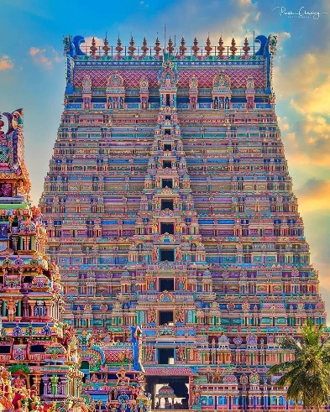

<https://i.redd.it/m5snsze7tfz41.jpg>

2nd image:

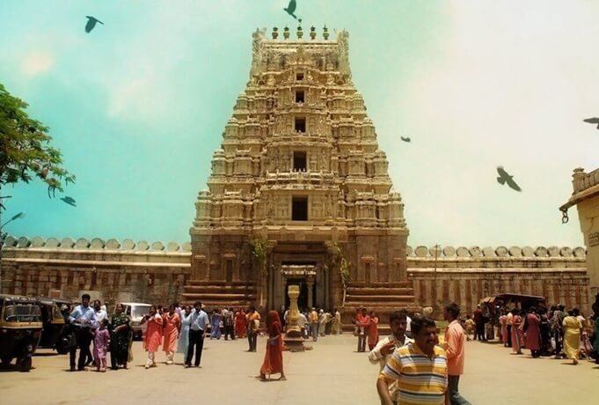

<https://www.indianeagle.com/travelbeats/wp-content/uploads/2017/11/Sri-Ranganathaswamy-Temple-Srirangam-UNESCO-Award-Merit.jpg>